**Configuring an Enterprise Egress Based on PPPoE Authentication**

Student Version



Huawei Technologies Co., Ltd.

|  |
| --- |
| **Copyright © Huawei Technologies Co., Ltd. 2020. All rights reserved.**  No part of this document may be reproduced or transmitted in any form or by any means without prior written consent of Huawei Technologies Co., Ltd.  **Trademarks and Permissions**  HW_POS_RBG_Vertical-150ppi.png and other Huawei trademarks are trademarks of Huawei Technologies Co., Ltd.  All other trademarks and trade names mentioned in this document are the property of their respective holders.  **Notice**  The purchased products, services and features are stipulated by the contract made between Huawei and the customer. All or part of the products, services and features described in this document may not be within the purchase scope or the usage scope. Unless otherwise specified in the contract, all statements, information, and recommendations in this document are provided "AS IS" without warranties, guarantees or representations of any kind, either express or implied.  The information in this document is subject to change without notice. Every effort has been made in the preparation of this document to ensure accuracy of the contents, but all statements, information, and recommendations in this document do not constitute a warranty of any kind, express or implied. |

|  |  |
| --- | --- |
| Huawei Technologies Co., Ltd. | |
| Address: | Huawei Industrial Base  Bantian, Longgang  Shenzhen 518129  People's Republic of China |
| Website: | <https://e.huawei.com/> |

**Huawei Certification System**

Huawei Certification follows the "platform + ecosystem" development strategy, which is a new collaborative architecture of ICT infrastructure based on "Cloud-Pipe-Terminal". Huawei has set up a complete certification system consisting of three categories: ICT infrastructure certification, platform and service certification, and ICT vertical certification. It is the only certification system that covers all ICT technical fields in the industry. Huawei offers three levels of certification: Huawei Certified ICT Associate (HCIA), Huawei Certified ICT Professional (HCIP), and Huawei Certified ICT Expert (HCIE). Huawei Certification covers all ICT fields and adapts to the industry trend of ICT convergence. With its leading talent development system and certification standards, it is committed to fostering new ICT talent in the digital era, and building a sound ICT talent ecosystem.

Huawei Certified ICT Associate-Datacom (HCIA-Datacom) is designed for Huawei's frontline engineers and anyone who want to understand Huawei's datacom products and technologies. The HCIA-Datacom certification covers routing and switching principles, basic WLAN principles, network security basics, network management and O&M basics, SDN and programmability and automation basics.

The Huawei certification system introduces the industry, fosters innovation, and imparts cutting-edge datacom knowledge.

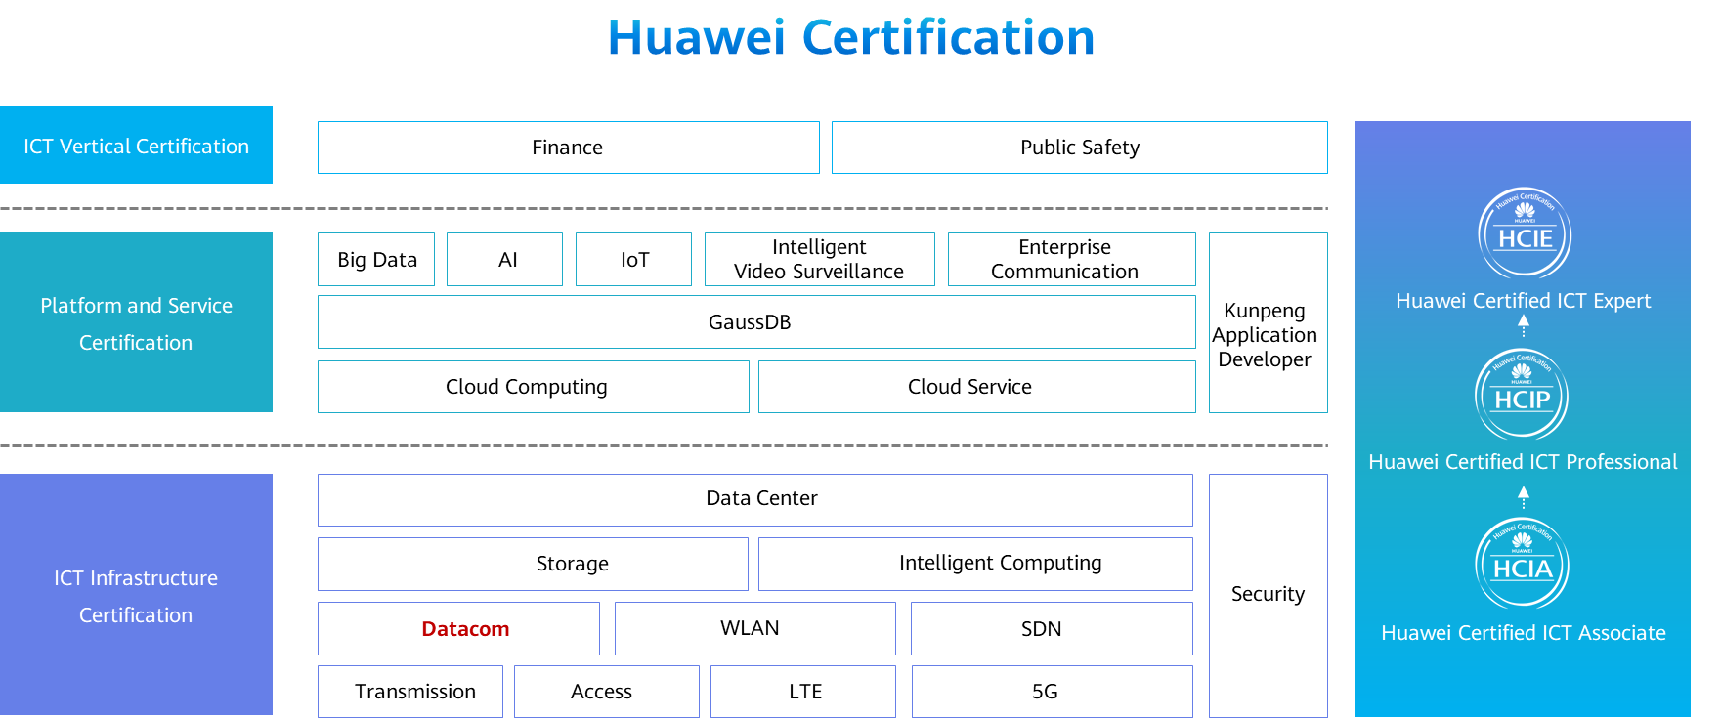

# Configuring an Enterprise Egress Based on PPPoE Authentication

## Background

The company Jan16 applies for a private line for Internet access from an ISP. The line uses PPPoE access. An egress router needs to be configured so that intranet users can access the Internet through this shared egress router. Figure 1-1 shows the topology. The following requirements must be met:

The egress router of the enterprise is connected to the ISP authentication server through G0/0/0.

The enterprise intranet is connected through an unconfigured switch to implement communication between clients and the gateway.

The IP addresses and interfaces of PCs and routers are shown in the following topology.

## Objectives

Upon completion of this task, you will be able to:

Learn how to configure PPPoE Server

Learn how to configure PPPoE Client

## Topology

Lab Topology

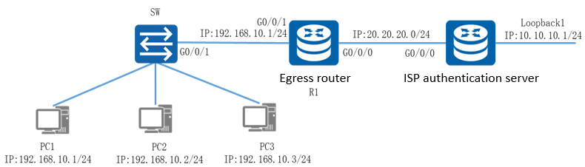

PPPoE access uses the PPP encapsulation protocol and can use PAP or CHAP authentication. CHAP authentication is more secure and is used here. To implement PPPoE access, create a dialer interface and configure the authentication mode, user name, and password. To implement interface sharing, configure an ACL to match intranet traffic and bind the ACL to the dialer interface. Then bind the dialer interface to G0/0/0 connected to an ISP server to implement link authentication. To enable the access from the intranet to the Internet, you need to configure a default route on R1 and specify the dialer interface as the outbound interface.

The IP address planning and interface planning can be referred in the appendix.

## Implementation

### Roadmap

1. Configure the PPPoE authentication server.
2. Configure the PPPoE client.
3. Configure IP addresses for PCs.

### Procedure

Configure the PPPoE server.

#Set a device name ISP for the router and configure an IP address for Loopback1.

[Huawei]system-view

[Huawei]sysname ISP

[ISP] interface LoopBack1

[ISP-LoopBack1] ip address 10.10.10.1 255.255.255.0

#Configure a global address pool on the PPPoE server to allocate IP addresses to PPPoE clients.

[ISP]ip pool pppoe

[ISP-ip-pool-pppoe]gateway-list 20.20.20.1

[ISP-ip-pool-pppoe]network 20.20.20.0 mask 255.255.255.0

#Configure PPPoE users so that the PPPoE server can authenticate the hosts.

[ISP]aaa

[ISP-aaa]

[ISP-aaa]

[ISP-aaa]

#Configure the virtual template (VT) interface and set the authentication mode of the local device to CHAP authentication.

[ISP]interface Virtual-Template 1

[ISP-Virtual-Template1]

[ISP-Virtual-Template1]

[ISP-Virtual-Template1]

#Enable the PPPoE server on GE0/0/0.

[ISP]interface GigabitEthernet 0/0/0

[ISP-GigabitEthernet0/0/0]

Configure the PPPoE client.

#Set the device name to R1 and configure the IP address of G0/0/1 as the gateway address for intranet users.

[Huawei]system-view

[Huawei]sysname R1

[R1]int G0/0/1

[R1-GigabitEthernet0/0/1] ip address 192.168.10.254 255.255.255.0

# Configure a dialer interface.

[R1]interface Dialer0

#Set up a PPPoE session.

[R1]interface GigabitEthernet0/0/0

[R1-GigabitEthernet0/0/0]

# Configure NAT on the device to translate LAN users' private IP addresses into public IP addresses so that the users can dial up to the Internet.

[R1]acl number 3000

[R1-acl-adv-3000] rule 5 permit ip source 192.168.10.0 0.0.0.255

[R1-acl-adv-3000]quit

[R1]interface Dialer0

[R1-Dialer0]

#Configure a static route to the PPPoE server.

[R1]

Configure IP addresses for PCs.

Configure the IP addresses of PCs referred by the appendix.

* 1. **Verification**

Check the PPPoE server session status and configuration.

#Run the **display pppoe-server session all** command on the ISP to check PPPoE session information.

<ISP> display pppoe-server session all

SID Intf State OIntf RemMAC LocMAC

1 Virtual-Template1:0 UP GE0/0/0 00e0.fcdc.5981 00e0.fc96.67e0

The command output shows that the session status is normal (**UP**) and the configuration is correct (consistent with the data plan and networking).

Check the PPPoE client session status and configuration.

#Run the **display pppoe-client session summary** command on R1 to check PPPoE session information.

[R1]display pppoe-client session summary

PPPoE Client Session:

ID Bundle Dialer Intf Client-MAC Server-MAC State

1 1 0 GE0/0/0 00e0fcdc5981 00e0fc9667e0 UP

The command output shows that the PPPoE client session status is normal (**UP**).

Test the interoperability of PCs.

#Ping the loopback address of the router from PC1.

[C:\~]$ ping 10.10.10.1

Ping 10.10.10.1: 32 data bytes, Press Ctrl\_C to break

From 10.10.10.1: bytes=32 seq=1 ttl=254 time=47 ms

From 10.10.10.1: bytes=32 seq=2 ttl=254 time=47 ms

From 10.10.10.1: bytes=32 seq=3 ttl=254 time=31 ms

From 10.10.10.1: bytes=32 seq=4 ttl=254 time=47 ms

From 10.10.10.1: bytes=32 seq=5 ttl=254 time=47 ms

--- 10.10.10.1 ping statistics ---

5 packet(s) transmitted

5 packet(s) received

0.00% packet loss

round-trip min/avg/max = 31/43/47 ms

The preceding output shows that PC1 can access the loopback address of the router.

## Appendix

IP address planning

| Device |  | Interface | IP Address |
| --- | --- | --- | --- |
| R1 |  | G0/0/1 | 192.168.10.254/24 |
| ISP |  | G0/0/0 | 20.20.20.1/24 |
| ISP |  | Lookback1 | 10.10.10.1/24 |
| PC1 |  | E0/0/1 | 192.168.10.1/24 |
| PC2 |  | E0/0/1 | 192.168.10.2/24 |
| PC3 |  | E0/0/1 | 192.168.10.3/24 |

Interface planning

| Local Device | Local Interface | Peer Device | Peer Interface |
| --- | --- | --- | --- |
| R1 | G0/0/1 | SW | G0/0/1 |
| R1 | G0/0/0 | ISP | G0/0/0 |
| ISP | G0/0/0 | R1 | G0/0/0 |
| ISP | Lookback1 | Null | Null |